Module 6: The Great Lake

Inland Aquatic Ecosystems
Many of us are more familiar with freshwater aquatic ecosystems than we are with saltwater ones. You may have spent many hours fishing, swimming, and/or boating in (on) your favorite lake or river. As you work through the material in this module, see if you can apply the information given to the lakes and streams that you have personally experienced.
The phenomenal Great Lakes that are shared by the United States and Canada will be the focus of this module. First, the basic ecology of the lakes will be explained and then several of the most significant problems that the area is experiencing will be addressed.

Types of Freshwater Ecosystems
Lakes are not the only type of freshwater ecosystem. There are also the familiar systems: ponds, rivers, streams, swamps, marshes and the more unfamiliar ones: bogs and fens. These systems differ from each other in various physical and biological aspects. Sometimes it's size alone that makes the difference - a lake being larger than a pond and a river being larger than a stream. Other times it is water speed that makes the difference. A lake has relatively still water while a river has moving water.
Swamp
The difference between swamps and marshes has to do with vegetation type that is found – swamps have large numbers of shrubs and trees while marshes have mostly grasses. Finally, bogs and fens differ in source of water – bogs get their water primarily from precipitation and fens get their water from springs and other ground water sources.
Marsh

Goods and Services
The goods and services provided by the Great Lakes mirror those provided by most large lakes. These lakes provide habitat to species that live in the lake year long and to ones that migrate over the lake spending days to months on and around the lake. These ecosystems also provide freshwater and food to terrestrial species including ourselves. Therefore, maintenance of biodiversity is a critical service provided. The lakes purify air and water and provide climate regulation as well. Water is retained by the lakes thus controlling erosion and flooding of surrounding areas. The lakes are also a source of atmospheric water due to evaporation of water from their surfaces. This is especially obvious during the winter when the lake-effect occurs. The term lake effect is generally used to describe increased snowfall events that occur downwind of large bodies of water. People living around the Great Lakes tend to either love or hate these lake effect snow events.
The decomposers living within the system process organic matter and other waste material cycling the nutrients back to the producers within the system that can use them along with sunlight to create food for the rest of the community and for us. The Great Lakes provide vast recreational opportunities to people who live near by or who visit the area. Adventurers enjoy fishing, hunting, swimming, boating, and even surfing in lakes that are more like in-land seas than they are like normal lakes. The lakes are also used to provide passageways between ports, and they are a source of hydrologic energy. The lakes have even been mined for minerals.
In conclusion the Great Lakes provide many important goods and services, and its immensely important that we realize that without conservation and restoration of these ecosystems that we could lose those assets before future generations could enjoy them.

Abiotic Conditions and Zonation of Lakes
Keep in mind the impact that abiotic conditions have on living things within an ecosystem. The abiotic conditions within a lake are affected by shape and size of the lake, by the geology of the land surrounding the lake, by adjacent communities, by the climate of the area, and of course, by man. The water that fills a lake enters by way of surface flow, atmospheric input, and groundwater delivery (springs, etc.), and it leaves by way of evaporation and river and/or stream outflow. A simple illustration of those flows is shown in the diagram. The relative rates of inflow and outflow determine the change in volume of the lake over time. Retention time (also called residence time) is a measure of how long a solute (molecule or compound dissolved in water) would stay within the lake once it entered it by way of the hydrologic cycle. Retention time is a factor of the volume of the lake and the rate of inflow and outflow. Typically, the larger and deeper a lake is the longer the retention time of solutes is. Retention time is an important consideration when pollutants enter the system.
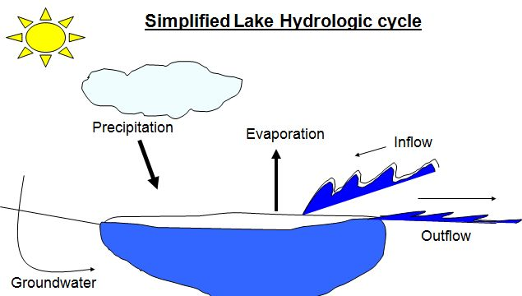
Ecologists typically divide large lakes up into zones – littoral , limnetic, profundal and benthic. The littoral zone is shallow water areas near shore. The limnetic zone is the upper portion of the water column found in the "open water" areas of the lake while the profundal zone contains the deeper portion of the water column in those same areas. Benthic is the term given to the bottom area throughout the lake. Abiotic conditions can vary significantly between zones within the same lake. Littoral and limnetic zones are areas that get enough sunlight to fuel photosynthesis. Water within these two zones is often warmed by the sun and usually contains suitable dissolved gas concentrations due to the photosynthesis that occurs here and to efficient atmospheric exchange.
Inorganic nutrients arrive into the system by way of runoff from the land, from wet and dry deposition from the atmosphere (precipitation and dust) and from nutrient cycling performed by decomposers within the community itself. The quantity of nutrients found in different zones of the lake depends on the amount of nutrients delivered, on the amount of mixing of the water column, on the rate of use of nutrients by producers, and on the rate of decomposition.
Naturally, large lakes tend to be oligotrophic which means they tend to have low nutrient concentrations and relatively low rates of primary productivity. The low nutrient situation in large lakes is linked to nutrient uptake abilities of surrounding communities. In undisturbed areas, lakes are surrounded by vast amounts of vegetation – forests, grasslands, and/or marshes that filter nutrients out of the water before it enters the lake. In these oligotrophic systems water clarity is high due to limited algae productivity, and bottom vegetation can occur at some depth providing food and habitat to the consumers within the lake.
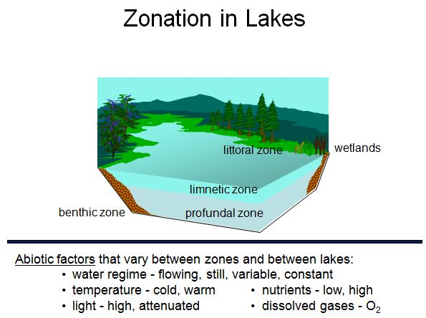

What are the Great Lakes Great?

The Watershed
The Great Lakes were designated by President George W. Bush as a national treasure in 2004 because of their beauty and their importance to the economy of the nation. Each lake within the system has its own watershed, or lake basin, and yet because water flows between the lakes, they also share a watershed.
The shared watershed is approximately 200,000 sq mi. Over 33 million people (> 10% of the population of the United States) live and work within the Great Lakes watershed. Approximately 40% of US industry and 50% of Canadian industry is located with this area. Although there is industrial and urban development in the area, other areas within the watershed contain productive farmland (~7% of US farmland) and vast forests.
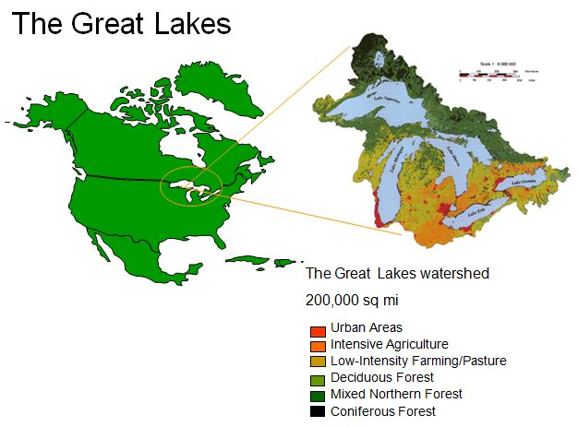
Image Credit: U.S. Army Corps of Engineers

The Lakes
The formation of the Great Lakes occurred fairly recently geologically speaking. During the last ice age a massive glacier, the Laurentide glacier, covered all of Canada and extended down into the United States (to about Chicago, Illinois). This glacier was ~2 miles thick. Approximately 14,000 yrs ago the climate began to warm and the glacier began to melt. The weight of the glacier had created large compressed areas of land and the melt water filled those areas as the glacier retreated. For a while, the lakes were even larger than they are today. It wasn't until several thousand years ago that the St. Lawrence River opened to the ocean and the levels of the lakes lowered. The land beneath the Great Lakes continues to rebound from the weight of the glacier at a rate of about 7.5 cm/yr which means these systems are still in a state of geologic flux.
The Great Lakes – Lake Superior, Lake Michigan, Lake Huron, Lake Erie, and Lake Ontario cover approximately 96,000 sq mi and hold 6 quadrillion gallons of water. This is approximately one-fifth (~20%) of the world's fresh surface water supply and nine-tenths of the United States' supply. If this water could be spread evenly over the surface of the lower 48 states of the US, the water would be about 9.5 feet deep. Isn't that incredible? Based on surface area these five lakes rank as some of the largest in the world. Lake Superior is the second largest lake (it’s actually the largest freshwater lake), and Lake Huron and Lake Michigan rank 5th and 6th, respectively. Lake Erie is ranked 12th and Lake Ontario is ranked 14th. The depths of the lakes vary from 1,330 ft (Lake Superior) to only 210 ft (Lake Erie) with Lake Michigan having a depth of 923 ft; Lake Huron, 750 ft; and Lake Ontario, 802 ft. Retention times follow volume with Lake Superior having the longest at 191 years and Lake Erie having the shortest at 2.6 years. Lake Michigan’s retention time is 99 years; Lake Huron - 22 years; and Lake Ontario - 6 years.
Map of the Great Lakes Basin
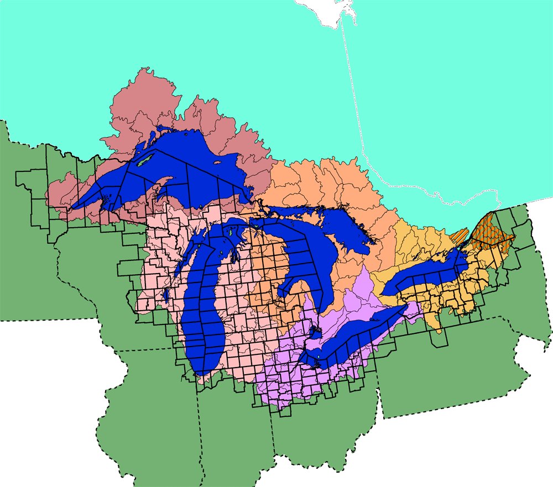
Image Credit: United States Environmental Protection Agency

Threats to the Great Lakes: Pollution (Historic)
The Great Lakes are currently experiencing severe environmental stress due to the growing human population in the watershed and in the world as a whole. It is estimated that restoration of this critical ecological area could cost over 20 billion dollars. (Source: Great Lakes Restoration Could Cost $20 Billion DULUTH, Minnesota, July 11, 2005 (ENS)).
In 2009 President Obama designated $475 million dollars and initiated an Action Plan for the Great Lakes to be administrated by the EPA.
"President Barack Obama has committed to making Great Lakes restoration a national priority. In February 2009, President Obama proposed $475 million for a Great Lakes Restoration Initiative, the most significant investment in the Great Lakes in two decades. The action plan, which covers FY 2010 through 2014 and was developed by 16 federal agencies as part of the federal inter-agency task force chaired by Administrator Jackson of the EPA, will help guide the administration's efforts to implement this historic initiative to restore and protect this natural and economic treasure."
- Source: https://dr6j45jk9xcmk.cloudfront.net/documents/834/guide-eating-ontario-sport-fishen.pdf)
Three of the most critical issues seen in the Great Lakes today are pollution, presence of numerous invasive species, and global climate change.

Pollution

History
Watershed activities have impacted the Great Lakes for over 150 years. First, from 1850 - 1880 virgin forests were lost due to extensive logging. The erosion that resulted clogged rivers and streams with sediment and altered water quality within the lakes. In addition, rivers and streams that were once shaded became exposed to the sun and their water temperatures increased making them less suitable to some native fish. Next, agricultural use of the land surrounding the lakes exploded in the late 1800's due to the significant growth of nearby cities. Heavy erosion occurred from the fields, and fertilizers added to the fields were delivered to the lakes along with the sediments. Eutrophication of some of the lakes resulted, and water quality declined as algal blooms occurred. As the cities continued to grow, rapid urbanization of the early to mid 1900's led to extensive chemical contamination of many of the lakes and sewage was a problem as well. Finally, later in the 1900's, the technological revolution led to further chemical contamination of the lakes with use and release of various toxic compounds such as PCBs, mercury, chlordane and dioxins.
In the mid 1900s there were signs that significant environmental damage had been done to the Great Lakes. In the 1960's significant eutrophication caused such extensive anoxia that Lake Erie was declared "dead". The label "dead" didn't mean that there wasn't anything living in the lake. It simply meant that many of the native fish had been killed by the anoxia that resulted from the overload of phosphorus which was caused by delivery of detergents and sewage into the lake.
Another hard to ignore situation was the burning of the Cuyahoga River (southern shore of Lake Erie) in 1968. This river had burned at least 9 different times since 1868, yet the fire in 1968 drew worldwide headlines and fueled the development of a Water Quality Agreement between Canada and the United States that would set limits on phosphorus and require the improvement of sewage treatment plants. It also spurred a tremendous grassroots effort to improve the overall environmental health of the Great Lakes.

Cuyahoga River Fire. Photo Credit: United States Environmental Protection Agency. Public Domain.
The abuse of the environment continued, however, and eventually the federal government had to establish superfund sites (circa 1980) that funded remediation of sites that had been significantly contaminated with hazardous material.
Human Population in the Great Lakes regions. Image Credit: EPA.

Threats to the Great Lakes: Pollution (More Recent Pollution Issues)
Despite regulations and agreements, the Great Lakes still have many point and non-point sources of pollutants. For example in 2002, 100,000 tons of toxic chemicals were released into air in the Great Lakes basin.
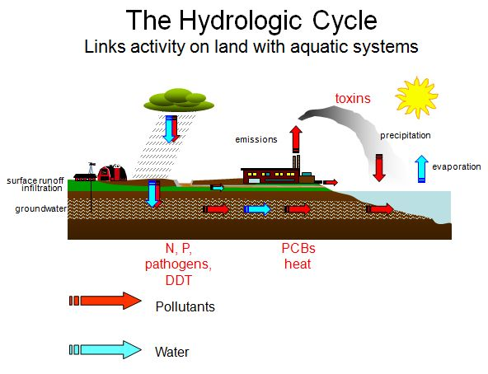
The hydrologic cycle and the atmosphere connect ecosystem with ecosystem. With as much human activity as there is on the Great Lakes watershed, it’s no wonder that the lakes, no matter how large they are, are being altered chemically. The table below shows the major categories of pollutants that affect the Great Lakes today. Specific examples within each category and sources for the contaminants are also given.
The problems associated with sediments (erosion), inorganic plant nutrients (nitrogen and phosphorus from fertilizers), and oxygen demanding wastes (sewage) have been covered in past modules that have also dealt with aquatic ecosystems and the effect that terrestrial input has on their function. However, the Great Lakes have also experienced high levels of pathogens and synthetic organic compounds (PCBs, dioxins), so these will be the pollutants covered in this section.
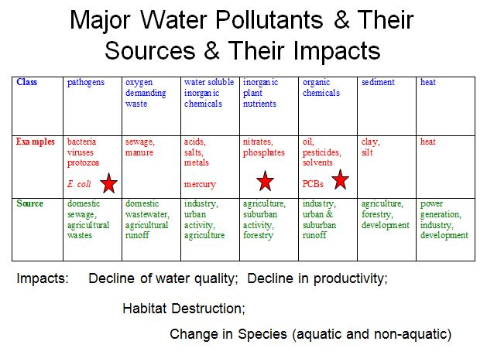

Threats to the Great Lakes: Pathogens
Pathogens (bacteria, viruses, etc.) not only affect the lake inhabitants but they affect and infect people who merely like to visit the shores to swim and play in the water. Infections caused by exposures to these pathogens include gastroenteritis, respiratory infections, and ear infections. In recent years the number of beach closings due to high levels of pathogens (mostly fecal coliform bacteria such as E. coli) has increased substantially. This does not mean specifically that the rate of contamination has increase just as substantially. A greater number of beaches are being tested and better standards are being used to determine closures, but that doesn't change the fact that pathogen contamination is a serious problem for many Great Lakes beach communities.
The source of these contaminants is typically untreated sewage and storm water runoff. Beach closings are economically painful to the businesses that cater to beach-goers. Depending on the size of the beach and the day of the year, a single day of beach closure on Lake Michigan has been documented to cost in the range of $8,000 to $37,000 in business.
Additional Information
(Not required; This is a long report but it is an excellent source of information)
- Great Lakes Water Quality Report

Threats to the Great Lakes: Metals and Synthetic Organic Compounds
Although there has been heightened awareness and significant legislation, the amount of chemical contamination in the Great Lakes is still at dangerous levels. The problems continue because:
- The area affected by over 100 years of neglect and abuse was large
- The cleanup process is difficult and costly
- Large numbers of people still live and work in the area
- Contaminants from as far away as China are transported to and are absorbed by these large bodies of water
The major chemical contaminants that lead to fish consumption advisories include mercury, PCBs, pesticides, dioxins and furans, which have been shown to damage to the nervous, respiratory and immune systems, as well as cause cancer. The analysis showed that while some areas, such as Lake Erie, have seen reductions in toxic contamination over time, a greater number of areas are becoming more polluted. Lake Ontario fared the worst, with eight categories of fish that became more contaminated between 2005 and 2007, and only one category that improved. As a general rule, advisory levels are more severe for larger fish, which are usually older and so have accumulated more toxins. But severe consumption advisories have been issued for even small sizes of fish in Lake Ontario.
Additional Information
(Required)
Click on the links below for more information.
- Eating Ontario's Sport Fish
- Mercury Levels in Great Lakes Fish on the Rise
The most troublesome chemical contaminants in the Great Lakes are the molecules and elements that bioaccumulate within tissues. Mercury, lead, dioxins, DDT, and PCBs are just some of the bioaccumulants found in these waters. Bioaccumulation (also called bioamplification and biomagnification) occurs when the chemical isn't metabolized by the organism that absorbs it. Instead these compounds being fat soluble, get stored within the fatty tissues of the organism. If organisms at the bottom of the food chain absorb these chemicals from the water, they accumulate higher levels than what is seen in the water. As predators eat large numbers of these guys, they (the ones higher on the food chain) end up with higher levels of the contaminant. This magnification of toxin concentration occurs as the biomass is passed up the food chain. By the time you get to top predators such as birds of prey and top carnivorous fish you may see thousands or millions of times higher concentrations of the toxin than what is measurable in the environment. The "fattier the fish" and/or "the older the fish" the more magnification of the toxin could have occurred.
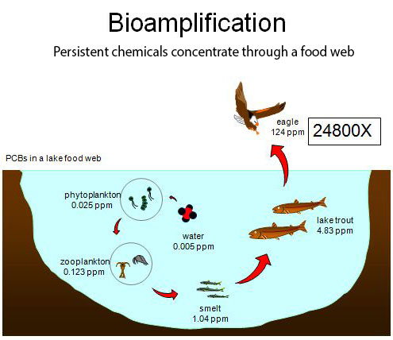

Threats to the Great Lakes: Metals and Synthetic Organic Compounds - continued
Bioaccumulating toxins and others settle in the soil and can get resuspended years after the pollution event occurred. Most of the problems with the EPA's 42 Areas of Concern along the shores of the Great Lakes have to do with sediment concentrations of contaminants. In areas with contaminated sediments, degraded fish and invertebrate populations are common, fish consumption advisories are necessary, and dredging activities are restricted.
Human health is not the only thing at risk due to the release and build up of these toxic chemicals. Wildlife, especially those species who feed at the top of the food chain, exhibit serious physiological changes with exposure to these compounds.
"There is no existing formal, long-term program for gathering evidence of the incidence and severity of the health effects of toxic substances in wildlife. However, research-based studies of bald eagles, herring gulls, night herons, tree swallows, snapping turtles, and mink over the past 30 years have revealed a broad spectrum of health effects in the Great Lakes-St. Lawrence basin including thyroid and other endocrine disorders, metabolic diseases, altered immune function, reproductive impairment, developmental toxicity, genotoxicity, and cancer. These effects occurred most often and were most severe in the most contaminated sites (Green Bay, Saginaw Bay, Lake Ontario, the St. Lawrence estuary, and more recently, Lake Erie), some of which are International Joint Commission-designated Areas of Concern (AOCs). In all cases, a strong argument can be made for an environmental etiology, and in many cases for the involvement of persistent organic pollutants, particularly polychlorinated biphenyls, polychlorinated dibenzo-(italic)p(/italic)-dioxins, and polycyclic aromatic hydrocarbons."
- Source: Wildlife as sentinels of human health effects in the Great Lakes--St. Lawrence basin. By Fox, G.A. 2001. Environ Health Perspective. Vol. 109 (Suppl. 6): 853-861. http://www.pubmedcentral.nih.gov/articlerender.fcgi?artid=1240620
To understand what is involved with restoring natural habitat after such severe contamination, read about one of the first cleanup projects that was completed.
"More than 470,000 pounds of contaminants were removed from the Black Lagoon inlet on the Detroit River, completing the first cleanup project made possible by the Great Lakes Legacy Act. U.S. Environmental Protection Agency's Great Lakes National Program Office and Michigan Department of Environmental Quality coordinated the removal of 115,000 cubic yards of polluted sludge from the small bay during the $9.3 million project."
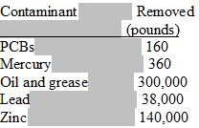
- Source: Detroit River's Black Lagoon Project; Authorized Legacy Act Project Site

Threats to the Great Lakes: Invasive Species
There are more than 180 introduced species (fish, invertebrates, aquatic plants, algae, pathogens) in Great Lakes. Many of these invasive species arrived by transport in ballast waters of ships. Ballast water levels have to be adjusted during cargo transport. When discharged, ballast water can release non-native species that were picked up in distant parts of the world. Ballast waters are not only the source of invasive species, but also of infectious diseases! In 2006, it became obvious that a new strain of the virus that causes viral hemorrhagic septicemia (VHS) was killing fish within Great Lakes. This virus infects many different species of fish and has a high rate of mortality. Although it hasn’t been proven that the new strain arrived in ballast water, it is known that it can be transported that way. Current regulations require vessels to exchange their ballast water with mid-ocean water before entering into the Great Lakes. The effectiveness of this practice varies because of participation and to the unfortunate fact that not all vessels are able to conduct exchange.
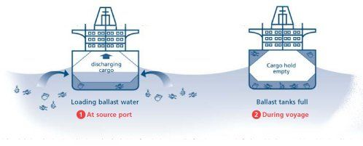
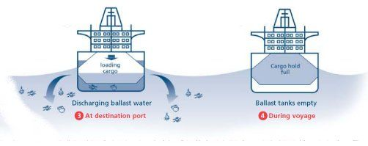
Image Credit: US Fish & Wildlife Service
To help prevent the introduction of additional foreign aquatic species into the Great Lakes ecosystem and other aquatic systems, new federal regulations on ballast water discharge standards are being developed by the United States’ Coast Guard and the Department of Agriculture's Animal and Plant Health Inspection Service (APHIS). Other agencies involved with this effort include the Environmental Protection Agency, the National Oceanic and Atmospheric Administration, and the U.S. Fish and Wildlife Service. Ballast water treatment technologies that have been considered are: use of biocides (chlorine and ozone), heat treatment, filtration, UV light exposure, and even use of acoustics.
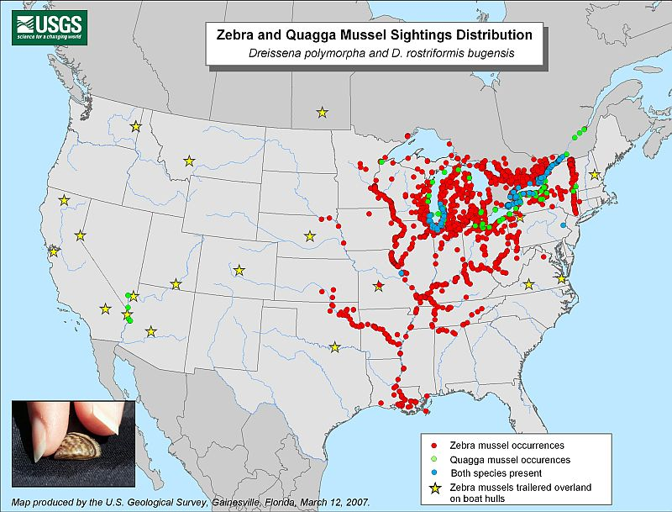
Image Credit: USGS

Link to more recent zebra mussel distribution map. (Required)
Millions of dollars are spent by state and federal governments every year on control and eradication measures for these invaders. This investment is required because of the seriousness of the resulting ecosystem disruptions. Some of the “new” species out-compete native species for resources (zebra mussels, European ruffe) while others (sea lamprey) parasitize or prey heavily on native species. Once even one native species has been affected by an invasive organism then the entire community may suffer from the consequences.
In the diagram the white blocks represent the native members of the community and the blue boxes represent the changes in population sizes that have occurred after introduction of an invasive species (zebra mussels). By feeding heavily on both phytoplankton and zooplankton populations the zebra mussels deplete food sources for every member of the community that feeds higher up in the chain. Remember that the community can be disrupted by bottom up effects (zebra mussels) and by top down effects (sea lamprey). The problems caused by invasive species are the focus of Readings I and II in this module.
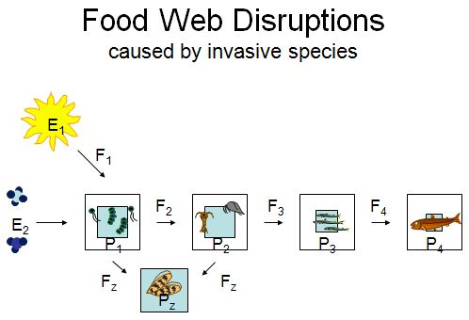

Module 6 Reading Assignments
Description:
You have three reading assignments for Module 6. Links for all the readings are given below. There is a Reading Quiz for Module 6. Note: I also posted an updated article on Lake Erie's 2021 algal bloom.
Instructions:
Click on the links shown below and read the information.
http://iaglr.org/releases/great-lakes-cleanup-leads-to-community-and-economic-revitalization/

https://www.nps.gov/miss/learn/nature/ascarpover.htm

https://weather.com/science/environment/news/2019-08-16-lake-erie-algal-bloom-space

Updated article for Lake Erie's 2021 algal bloom.

Threats to the Great Lakes: Global Climate Change
The Great Lakes and the basin that surrounds them may be significantly impacted by global climate change. Some researchers believe that changes are already measurable. For the last twenty years, warmer than average winter temperatures have been recorded. Tundra swans, that typically over winter in the Chesapeake Bay, are choosing not to migrate away from the Great Lakes in November. They stay throughout the winter often experiencing severe weather in January and February. Lake Superior's water level has dropped an amazing two feet during the last decade. Increased rates of evaporation during the winter months due to warmer air temperatures and reduced ice cover and reduction in spring runoff due to a smaller snow pack are thought to be the main causes for the decline. This change in water level is detrimental to the environment and to the economy of the region. Ships arriving to port can't carry a full load because if they did they wouldn't have enough clearance to make it to the docks and piers. A 2007 study by a group of researchers at the University of Minnesota, Duluth showed that summer surface temperatures of Lake Superior have increased approximately 2.5°C since 1979, roughly twice the rate of regional atmospheric warming.
With continued climate change, it is feared that the changes mentioned above will intensify and others will arise. It is predicted that the change in water temperature will threaten survival of cold tolerant aquatic species, changes in air temperature and moisture will alter forest community structure, and continued decreases in water level will just make the pollution problems within the lakes even more dangerous.
Additional Information
(Not Required)
- Climate Change Impacts on the Great Lakes

Ecosystem Restoration
Serious efforts to clean up the Great Lakes began in the 1970's. The EPA and nine other federal (US) agencies administer some 140 programs that fund and implement environmental programs in the Great Lakes basin! The EPA has a Great Lakes National Program Office (GLNPO) which oversees the Areas of Concern (AOCs). Mentioned earlier in the modules, the AOCs are 43 sites on the shores of the Great Lakes that have, because of one or many environmental issues, impaired ability to provide the beneficial services typically provided by these types of natural areas. Each AOC has its own Remedial Action Plan (RAP). Identified in 1987, restoration work is still being done on all but one of these sites.
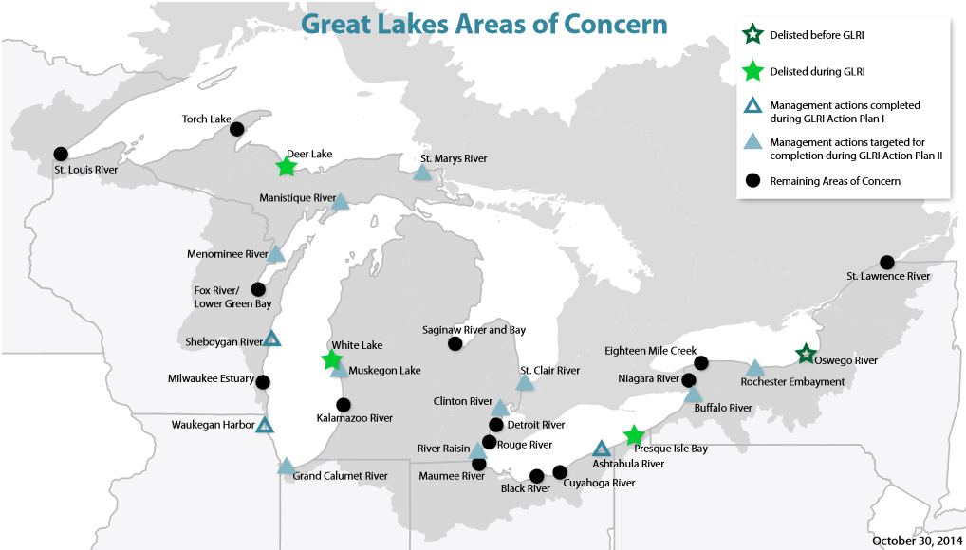

Image Credit: EPA
Because the Great Lakes' watershed covers land in both the United States and Canada, regulatory measures require agreement and commitment from both governments. In 1997 the Great Lakes Binational Toxics Strategy pledged collaboration among governments, First Nations and Tribes, and industries to work for the virtual elimination of persistent toxic substances resulting from human activities.
With so many plans in place and so many agencies involved, it was feared that time and money was being wasted due to the lack of coordination between groups. In late 2004 the Great Lakes Regional Collaboration (GLRC) was established by President Bush. The collaboration involved federal, state, city, tribal and nongovernmental partners. Over 1,500 people worked for over 6 months to prepare a coordinated plan of action and they called it the The Great Lakes Restoration Initiative Action Plan I (2010 – 2014). Following that work, The Great Lakes Restoration Initiative Action Plan II (2014 – 2019) was produced to continue the essential restoration effort in the area.
Although the problems within the Great Lakes may seem overwhelming - chemical pollution lingers, invasive species numbers are rising, and climate change threatens the functional capacity of the system, it does not mean that residents of the basin and of the countries have given up the fight. As shown by the details of the restoration plans, tremendous effort is currently being made to correct for abuses of the past and to prevent further damage to the system.

